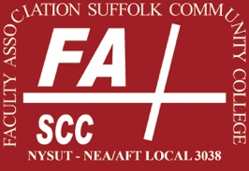 | FA Election 2024 Nomination Form

Type your nominations and return form return this form before March 1 at 11 am by email (cynthia@fascc.org) or deliver it in a sealed envelope to the attention of Cynthia Eaton at the FA office, Southampton 224J, Suffolk Community College, 533 College Road, Selden NY 11784.
You may only nominate EC reps in your own area; outside nominations will be disregarded.
Nominators and nominees must be FA members in good standing.

Full-time Executive Council Representatives

Ammerman Campus
Accounting, Business Admin., Business Information Systems, Legal Studies
Music, Visual Arts, Theatre, Philosophy, Women’s Studies
Nursing, Health and Human Services, Phys Ed
Engineering, Computer Science, Industrial Technology
Biology and Physical Sciences
English
Eastern Campus
Library, Humanities, Counseling

Grant Campus
Nursing, Health Science, Phys Ed, Veterinary Science
Library, Counseling, Media
Humanities

College-wide Constituent-based Executive Council Representatives
Technical Areas, Instructional Centers
Adjunct Executive Council Representatives

Business, Accounting, Communications, Telecom
Nursing, Phys Ed, Health Sciences
Foreign Languages, ESL, ASL, Reading
Social Sciences
PAs & Specialists – Instructional Labs
PAs & Specialists – Skills Centers
Guild, Retirees, and PAs & Specialists – Programmatic

Signature required if printing and returning to FA office. If returning by email, this form must be sent from your official SCCC or FA email account (to verify identity) to cynthia@fascc.org.

Print Name

Signature Date

