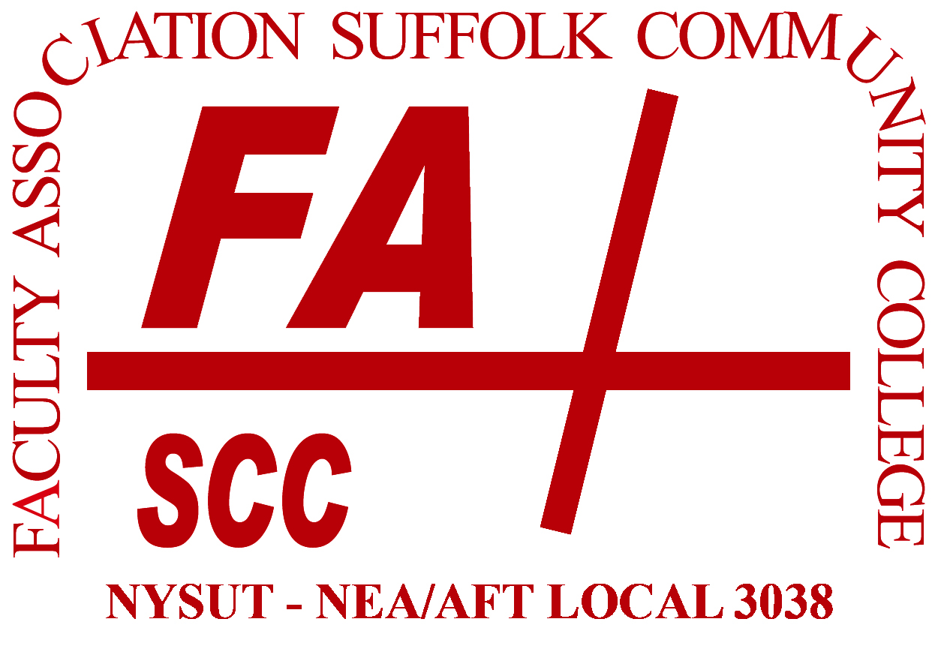 | FA Election 2020  Nominations Form

Type your nominations and return form no later than March 1 at 12 noon to the FA office:

- By email: | anita@fascc.org
- By foot or by  interoffice mail: | Southampton 224J, Ammerman
- By post office: | Faculty Association, Southampton 224J  Suffolk County Community College  533 College Road  Selden, NY 11784

- You may only nominate EC reps in your own area; outside nominations will be disregarded.
- All nominees must be members in good standing.

Full-time Representatives: Ammerman

- Accounting, Business Admin., Business Information Systems,
Legal Studies
- Music, Visual Arts, Theatre, Philosophy, Women’s Studies
- Nursing, Health and
Human Services, Phys Ed
- Engineering, Computer
Science, Industrial Technology
- Biology and Physical Sciences
- English
Full-time Representatives: Eastern
- Library, Humanities, Counseling

Full-time Representatives: Grant
- Nursing, Health Science,
Phys Ed, Veterinary Science
- Library, Counseling, Media
- Humanities

College-wide Constituent-based PA & Specialist Representatives

- Technical Areas, Instructional Centers

College-wide Adjunct Executive Council Representatives

- Business, Accounting, Communications, Telecom
- Nursing, Phys Ed, Health
Sciences
- Foreign Languages, ESL, ASL,
Reading
- PAs & Specialists – Instructional Labs
- PAs & Specialists – Skills Centers
- Social Sciences
Sign and return to FA office: | ______________________________________________________

