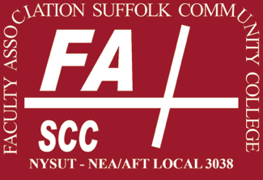 | Faculty Association &  Guild of Administrative Officers  Professional Development  Application
Use this form to apply for faculty development funding.

Faculty development is considered to include, but be not limited to, any courses or workshops that will enhance your professional performance. This funding will not be approved for coursework intended to fulfill educational promotion requirements.

All questions must be completed in order for your application to be considered. Do not include links to external sources; incorporate all information into this form. This form must be submitted electronically to Kelly Corrado in the Office of the Vice President for Academic Affairs (corradk@sunysuffolk.edu • 631-451-4737) no later than April 15.

Date of Application:
Affiliation: | - Faculty Association |  | - Guild
Intended Semester  of Development: | - Summer |  | - Fall |  | - Spring

Name
Discipline
or Area
Degrees | degree |  | field |  | year awarded

Proposed
Development
Area

- Describe the professional activity you plan to attend for faculty development. Attach a full description if necessary.
- Describe your previous experience and education related to the proposed development area.
- Identify the specific goals you hope to achieve in this proposed faculty development activity.
- Explain how this proposed faculty development activity will enhance your skills in your discipline or area of responsibility.
- Describe how completion of this proposed faculty development activity will benefit the college.
- Provide specific estimates, with documentation, of any or all associated costs for this professional development activity.
- If you anticipate any need for reassigned time, provide a detailed justification of this necessity.

I have reviewed the contract language, Article V.D.5, relating to Faculty Development and Retraining Leaves and I understand that a written report will be required within eight weeks of completing this faculty development activity.
signature |  | date

